**Healthy Hearts: Change today for a better tomorrow.**

**PROJECT REPORT**

Submitted in partial fulfillment of the requirements of the degree

**BACHELOR OF ENGINEERING IN**

**INFORMATION TECHNOLOGY**

By

SOHAM AMARE - 06

AARNA BAFNA - 11

SHAWN DCOSTA - 26

SHIVAM KILLARIKAR - 66

Guide

### Prof. Archana Kale

### 

Department of Information Technology

**Thadomal Shahani Engineering College**

Adv. Nari Gursahani Marg, TPS III, Off Linking Rd, Bandra West,

Mumbai, Maharashtra 400050



**University of Mumbai**

(Academic Year 2022-23)

# CERTIFICATE

This is to certify that the Mini Project entitled **“Healthy Hearts: Change today for a better tomorrow.”** is a bonafide work of **Soham Amare (06), Aarna Bafna (11), Shawn Dcosta (26), Shivam Killarikar (66)** submitted to the University of Mumbai in partial fulfillment of the requirement for the award of the degree of **“Bachelor of Engineering”** in **“Information Technology Engineering”.**

#### Prof. Archana Kale Prof. G. T. Thampi

Project Guide Principal

#### 

# Mini Project Approval

This Mini Project entitled **“Healthy Hearts: Change today for a better tomorrow.”** by **Soham Amare (06), Aarna Bafna (11), Shawn Dcosta (26), Shivam Killarikar (66)** is approved for the degree of **Bachelor of Engineering** in **Information Technology Engineering.**

**Examiners**

**1………………………………………**

Prof. Archana Kale

#### 2…………………………………………

(External Examiner name & Sign)

Date: 4 November, 2023

Place: Mumbai

## ACKNOWLEDGEMENT

This project has consumed a significant amount of time and resources, and we would like to thank everyone who has contributed to its success. We would like to express our deepest gratitude to the project head, **Prof. Archana Kale** for histime, patience and direction, as well as for inspiring us throughout. Without their guidance and support, this project would not have been possible. Their expertise, insights, and encouragement were invaluable in helping us navigate the various challenges and complexities of this project.

We would also like to extend our sincere thanks to the many research papers that we consulted throughout the course of this project. The insights and ideas presented in these papers were instrumental in helping us develop a deeper understanding of the subject matter and in shaping the direction of our research.

We are also grateful to our colleagues and friends who provided us with valuable feedback and support throughout the project. Their encouragement and insights were invaluable in helping us refine our ideas and in pushing us to achieve our best work.

**ABSTRACT**

"Healthy Hearts: Change today for a better tomorrow" is a Java-based GUI-application designed to promote overall well-being. This innovative application offers a range of features to help users enhance their fitness and lead healthier lives.

The core features of the "Healthy Hearts" include:

1. BMI Calculator:

- Users can input their height and set their weight accordingly, which in return will calculate their BMI and display it along with the weight-range in which they fall into.

2. Calorie Counter:

- Calorie Counter provides the nutritional value of the food ingredients input by the user, which is stored in a table from where the user can view it and gain information about the food user will consume.

- User can select from a wide variety of food items stored in our database.

3. A-Z Exercises:

- This part of the application consists of alphabets from A-Z, the user upon clicking on any alphabet is redirected to a page containing a set of 5 exercises from that respective alphabet.

4. Meal Tracker:

- The user inputs the day, date, meal, dish and calories which is stored in a table. Using this feature the user can keep a track on a daily basis of the food and the amount of calories he/she is consuming.

"Healthy Hearts: Change today for a better tomorrow" is user-friendly and suitable for individuals of all fitness levels. Whether you're a seasoned fitness enthusiast or just starting your journey toward a healthier lifestyle, this Java-based application is a valuable tool to help you achieve your health and fitness goals.

# Contents

# Chapter 1 Page No

* 1. Introduction 1
  2. Motivation 1
  3. Problem Statement & Objectives 1
  4. Organization of the Report 2

#### Chapter 2

* 1. Survey of Existing System 4
  2. Limitation Existing system or research gap 4
  3. Mini Project Contribution 4

#### Chapter 3

* 1. Proposed System 5
  2. Architecture/ Framework 6
  3. User Flow 8
  4. Database Structure 9
  5. Results 10
  6. Conclusion and Future work 14
  7. References 15

|  |  |
| --- | --- |
| **List of figures** |  |

### 

|  |  |  |
| --- | --- | --- |
| Fig No. | Title | Page No. |
| 3.4.1 | Queries | 9 |
| 3.4.2 | Food Calories | 9 |
| 3.5.1 | Launch gage | 10 |
| 3.5.2 | Registration page | 10 |
| 3.5.3 | Login page | 11 |
| 3.5.4 | Dashboard | 11 |
| 3.5.5 | BMI Calculator | 12 |
| 3.5.6 | Calorie Counter | 12 |
| 3.5.7.1, 3.5.7.2 | A-Z Exercises | 13 |
| 3.5.8 | Meal Tracker | 14 |

**CHAPTER 1**

* 1. **Introduction**

Fitness is a very important part in one’s life journey. People from different age groups can use various apps to remain fit now-a-days. However, there is a dearth of apps for this purpose that provide various features to track one’s well-being.

Our aim in choosing this problem statement is that Fitness is something that is being ignored lately and people are not concerned about their health. However with consistent efforts daily one can be fit and bring out the best version of themselves. For this purpose we have come up with our app which is user-friendly and will help the user to remain consistent.

### Motivation

### The journey to a healthier lifestyle is a crucial endeavor, impacting both personal well-being and professional success. Building healthy dietary habits is a vital part of this journey, enabling individuals to take charge of their health, form strong connections with their bodies, and achieve transformative results. However, many people struggle to maintain a balanced diet due to various challenges and uncertainties.

### Without proper support and guidance, it can be difficult for individuals to overcome these obstacles and improve their eating habits. This is why the creation of the Healthy Hearts app, which provides assistance in building a nutritious diet, can be a game-changer. It can empower individuals to conquer their dietary challenges, enhance their nutrition, and ultimately reach their health and wellness goals.

### Problem statement and objectives

### Many individuals struggle to maintain a healthy lifestyle and achieve their fitness goals due to a lack of convenient and user-friendly tools to help them track and manage their fitness and nutrition. To address this issue, we aim to develop the "Healthy Hearts" fitness app, which will offer a comprehensive set of features including a BMI Calculator, Calorie Counter, A-Z Exercises, and Meal Tracker. The problem we intend to solve can be defined as follows:

### "Despite the growing awareness of the importance of maintaining a healthy lifestyle, individuals often face challenges in managing their fitness and nutrition effectively. They lack a centralized, user-friendly, and comprehensive solution that caters to their fitness and dietary needs. This deficiency in accessible tools hinders people from reaching their health and fitness goals, which can lead to health issues and reduced quality of life. To address these challenges, our fitness app 'Healthy Hearts' aims to provide a one-stop solution for users to calculate their BMI, track their calorie intake, access a diverse range of exercises, and monitor their meals. By offering these features, we intend to empower individuals to take control of their health and well-being, ultimately promoting a healthier and happier lifestyle."

### The "Healthy Hearts" app will strive to simplify the fitness and nutrition management process, making it more accessible, engaging, and effective for users, with the ultimate goal of contributing to improved overall health and well-being.

### Objectives

* Develop an app that can keep a track of users' diet and provide the calculation of their BMI , nutritional values of various food items and giving them a set of exercises to perform.
* Display the above data in tabular form for easy comparisons.
* Provide a feature for storing their data entries.
* Track their progress over time

### Organization of the report

### This report is divided into three chapters. The first chapter covers the project's introduction, problem description, motivation for the topic, and objectives. The second chapter is a review of the literature. It contains all of the research effort done on this topic. This chapter covers all you need to know about studying current systems and learning new technologies. The third chapter describes the suggested system that will be employed in this project. This chapter contains screenshots of the project's block diagram, methodologies, hardware, and software. All materials referred and utilized in the development of this project are included in the references section.

### CHAPTER 2

* 1. **Survey of existing system**

MyFitnessPal is an app that offers services similar to our application. MyFitnessPal is a comprehensive health and fitness app that helps users track their diet, exercise, and overall wellness. It offers a food database, calorie tracking, and exercise logging.

Users can also set personalized health goals and receive support from a community of fellow users. MyFitnessPal focuses on enhancing overall health and fitness through tracking and goal setting.

### Limitation of existing system or research gap

MyFitnessPal is a decent app with lots of useful features. However, it must be noted that most of these features are simple.

Our app has more enhanced BMI Calculator and Calorie Counter provides more nutritional values than MyFitnessPal.

### Mini project contribution

Healthy Hearts is a user-friendly app for health enthusiasts. It helps users monitor their diet, offering a wide food database with nutritional information and calorie tracking. The app also provides a diverse range of exercises for all fitness levels, and a precise BMI calculator to classify users' weight status from Underweight to Obesity.

### CHAPTER 3

* 1. **Proposed system**

Our project Healthy Hearts is a user friendly application for people who are serious in having a healthy lifestyle. It enables the user to maintain records of their diets and keep a track on the amount of calorie they intake. The users can select from the wide variety of food items stored in our database and also get the nutritional values and the amount of calories it contains. Users are also benefitted with the feature of exercises in each alphabet from A-Z, thus a beginner can train daily without worrying what exercise he needs to do. We also have a BMI calculator, which calculate the BMI of the user and shows the weight-range in which the user belongs, from Underweight to Obesity.

The features available to user are:

* **BMI Calculator**: To calculate BMI.

#### Calorie Calculator: To attain nutritional values and calories.

#### A-Z Exercises: Sets of exercises alphabetically arranged.

#### Meal Tracker: Track meal and calorie intake on daily basis.

### Architecture / Framework

**Java SWING:**

Java Swing is an excellent option for GUI development, providing a contemporary and adaptable platform. Featuring a vast array of UI components, it eases the process of creating user-friendly interfaces. Java Swing also boasts support for multimedia, 2D and 3D graphics, as well as animations, making it the perfect choice for crafting captivating interfaces. Its event-driven architecture ensures the responsiveness of your applications, and its cross-platform compatibility guarantees a wide user base. To sum it up, Java Swing simplifies GUI development, elevating user experiences and expanding application accessibility.

**Java Programming Language:**

The Healthy Hearts project's business logic found a robust foundation in the Java programming language, renowned for its reliability and cross-platform compatibility. Java's stringent type-checking and exceptional error-handling capabilities bolstered the project's dependability. Furthermore, its vast array of libraries and tools expedited development and enhanced performance. This decision paved the way for the development of a secure and scalable fitness software solution, minimizing errors and enabling smooth integration with other Java-based technologies and frameworks. Consequently, Java proved to be an excellent choice for managing the intricate fitness features at the core of the project.

**MySQL:**

The Healthy Hearts project's database was meticulously designed using MySQL, a well-established and highly scalable database system, making it an ideal choice for fitness applications. MySQL's robust SQL support simplifies complex data operations, ensuring data security and adaptability for future expansion, a critical requirement for any evolving fitness project. This deliberate choice not only guarantees the project's success but also enhances its reliability and performance, establishing a strong foundation for handling the intricate fitness data at the core of the Healthy Hearts project. MySQL's renowned reputation for reliability and versatility, coupled with its extensive ecosystem of tools, solidifies its position as the perfect database solution for this application.

### User Flow

**Launch page**

Firstly, the user is welcomed by a launch page which has a loading frame, which on completion redirects the user to the login page.

**Login and Register**

Next, the user has to log in with a username and password. If the user doesn't have an account the user will create a new account by filling up some credentials like name, surname, username some security questions and then setting a password for the account.

#### Dashboard

Once the user has logged in, the user will arrive at the dashboard. Now the user has four options.

**First** is the BMI Calculator where the user can calculate his/her own BMI.

**Second** is the Calorie Counter where the user can know the nutritional values of food items as well as its calories. **Third** is the A-Z Exercises where the user can daily hit a set of distinctive 5 exercises as per his/her own choice. **Last** **but not the least** is the feature of Meal Tracker where the user can keep an account of what food he/she intakes and the amount of calorie they consume.

### DATABASE STRUCTURE

### C:\Users\soham\AppData\Local\Packages\5319275A.WhatsAppDesktop_cv1g1gvanyjgm\TempState\6EA9AB1BAA0EFB9E19094440C317E21B\WhatsApp Image 2023-11-03 at 13.26.39_d2024e8a.jpg

### 3.4.1 Database structure 1

### 3.4.2 Database structure 2

### RESULTS

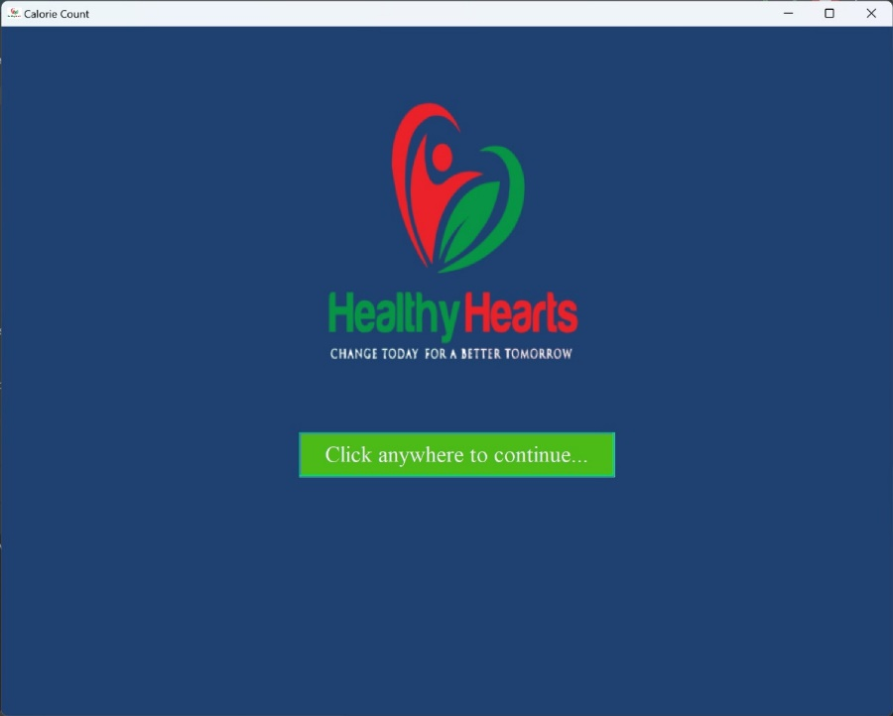

* + 1. Launch page

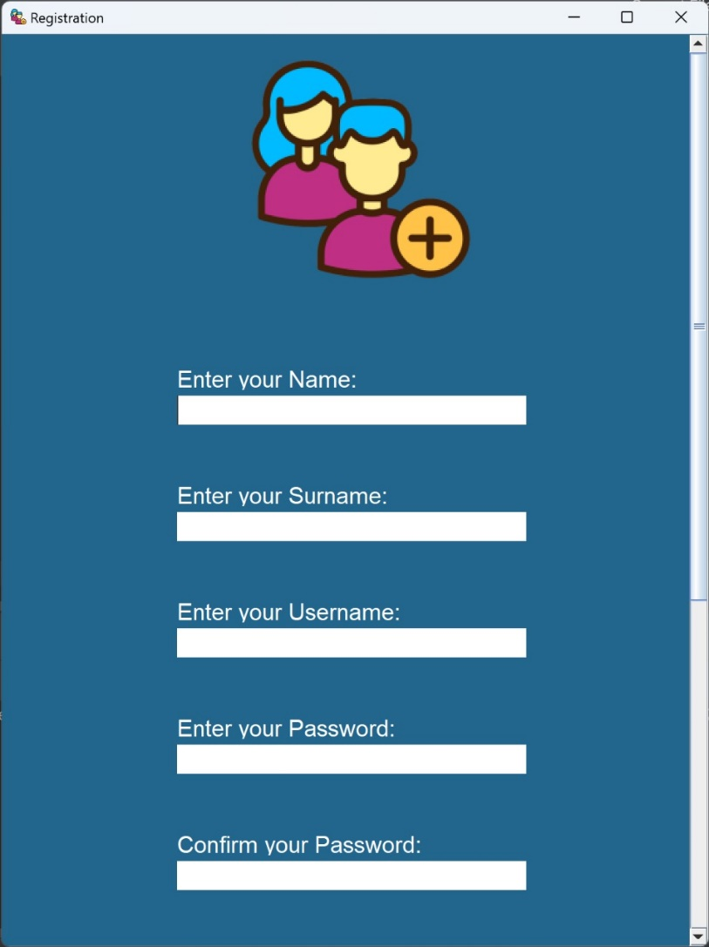

* + 1. Registration Page

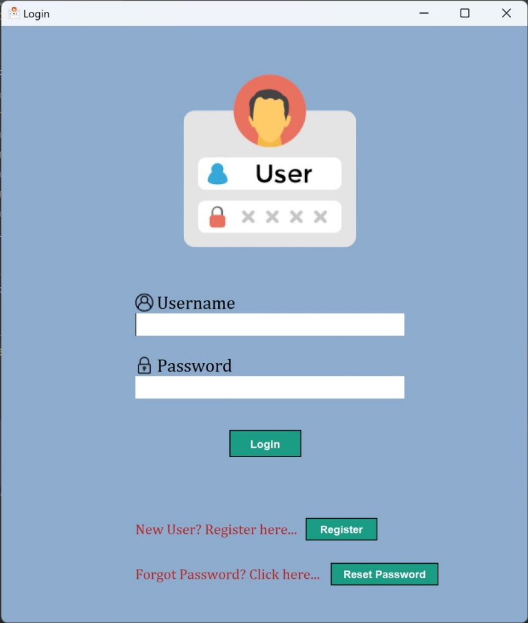

* + 1. Login Page

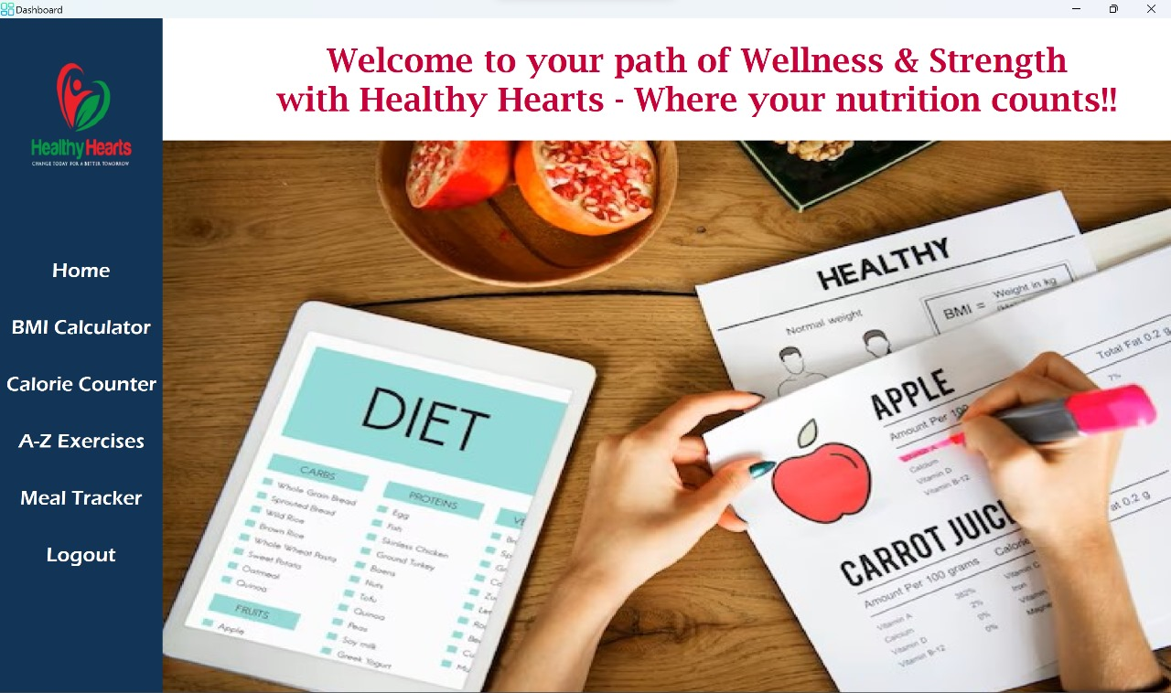

* + 1. Dashboard

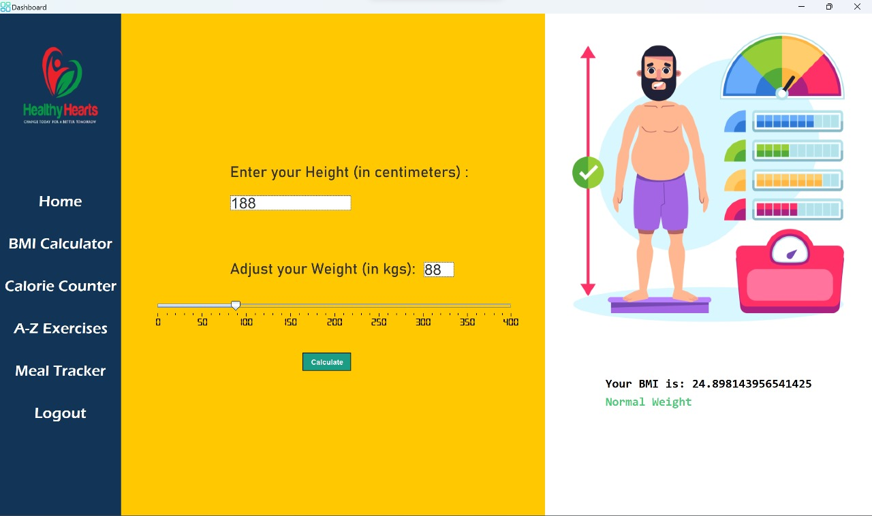

**3.5.5** BMI Calculator

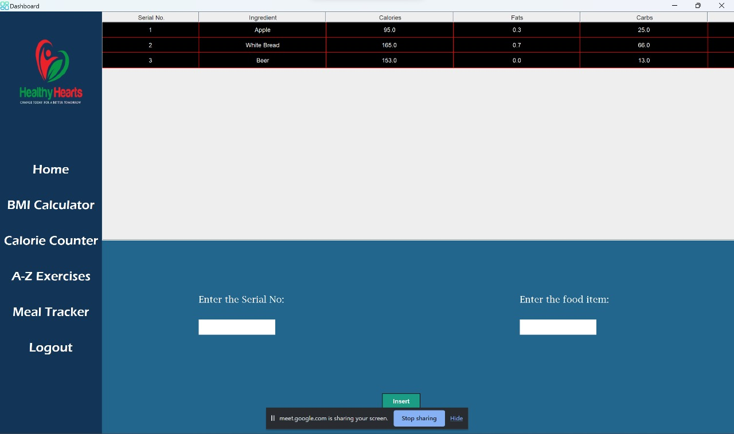

**3.5.6** Calorie Counter

**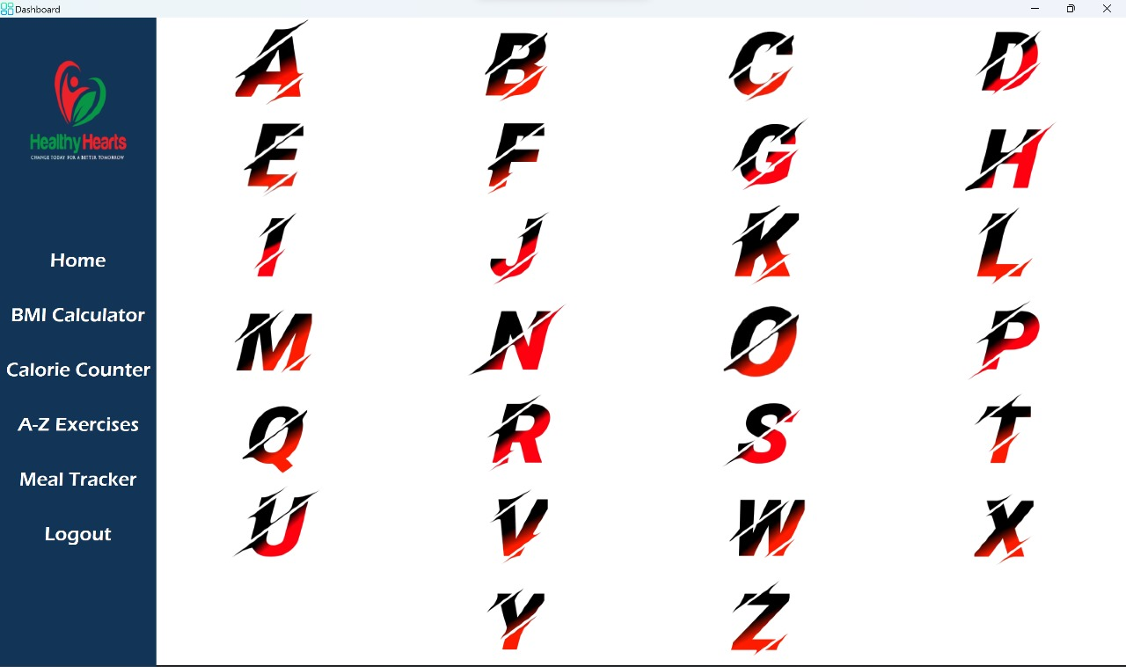**

**3.5.7.1**

**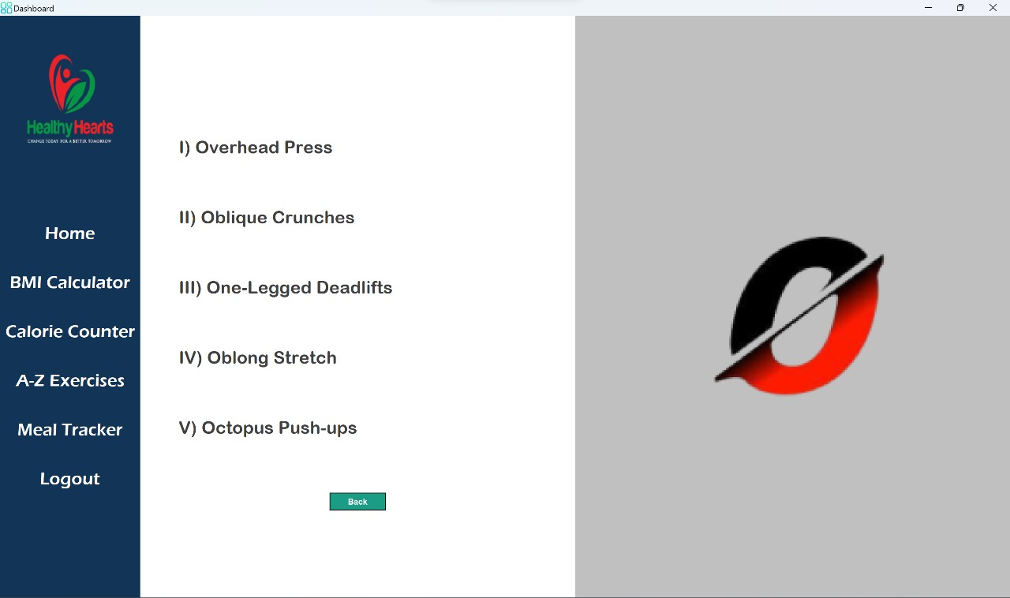**

**3.5.7.2** A-Z Exercises

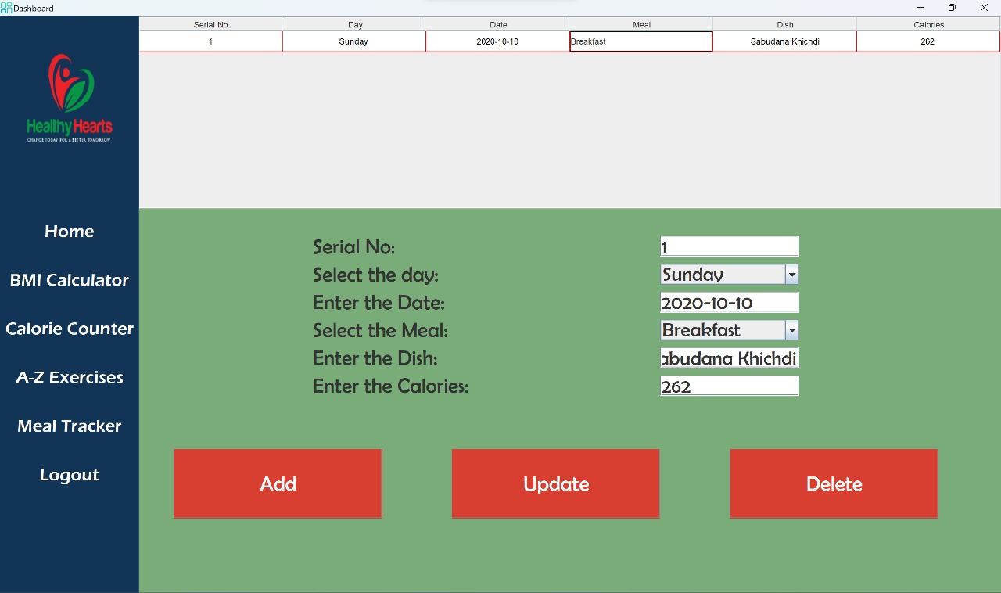

**3.5.8** Meal Tracker

### CONCLUSION AND FUTURE WORK

To conclude, Healthy Hearts is an app that aims to motivate users and help them to improve their fitness and well-being. The application aims to help the user have a better tomorrow by motivating them to change today, which is also the application’s motto. The project offers a wide variety of distinctive features which endeavors to help users in their fitness journey. Also, the app provides features so that the user is able to track their progress and make improvements on daily basis.

The project has a very vast scope for expansion in the future:

1) Expanding the database to access new food items and their nutritional values.

2) To set a daily calorie intake limit in our feature ‘Meal Tracker’.

3) Improving attractiveness.

4) Improving ‘A-Z Exercises’ feature by adding media.

### REFERENCES

[1] <https://fdc.nal.usda.gov/fdc-app.html>

#### [2] <https://www.nutritionix.com/>

[3] <https://colorhunt.co/>

[4] <https://www.myfitnesspal.com/>